Brief Curriculum Vitae

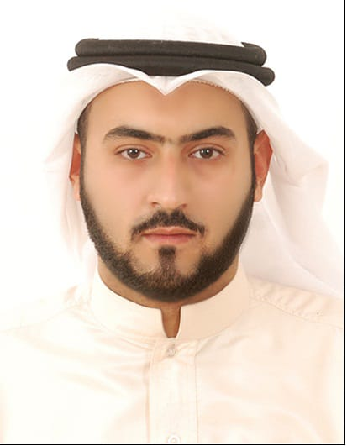
NAME : Ali Hussain Jassim Hassan Al-Aradi

CPR . # : 930200489

Date of Birth: February 12th , 1993

NATIONALITY: Bahraini

M. STATUS: Married

ADDRESS: House # 2135, Road # 4147, Arad 0241

CONTACTS: Mobile: 32260333 - 33175305 – e-Mail: aharadi45@gmail.com

Education & Qualification | Al-Hidaya Al-Khalifa Secondary School - (Tawjihi)
IT Knowledge | Computer Principles & Operating System  Word Processing using MS-Word  Spreadsheets using MS-Excel  Databases using MS-Access  Computer Graphics using MS-PowerPoint  Desktop Publishing: MS-Publisher, Photoshop & Drawing Corel Draw  Communication using Outlook  I am fully computer literate with knowledge of most Microsoft Windows applications .
Skills and Abilities | Personal Qualities:  Ability to lead groups and design the plans and structures for them.  Good personality where I can mix with any type of people.  Decision making on how organizational decisions should be made.  Communication Skills  Perfect listening skills  Public speaking skills and ability to make presentations.  Build trusted business advisor relationship with key decision makers to eliminate proposal requirements.  Language Skills  Perfect knowledge of English, Arabic.  Basic knowledge of Persian and Indian  Interpersonal Skills  Dynamic in style and approach.  Proactive and lateral thinking.  Ability to solve problems and elevate obstacles.  Highly Adaptive.  Persuasive skills.  Stakeholder interest focused.  Read and Understand financial reports and concepts.
Work Experience | October 2012 – January 2015 Raheem Construction Company.  October 2012 – To date Clearance of government documents and  customs

